Installing QWS3270secure.exe (version 4.6)
- Download and install the qws3270secure.exe from https://software.ucdavis.edu/index.cfm
- Click Next at the welcome screen
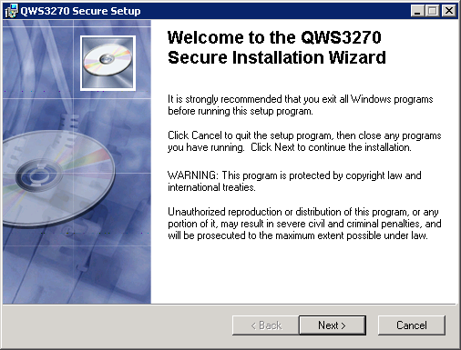
- Click Accept at the License agreement window and click Next
- Accept the default for the User Information screen and click Next.
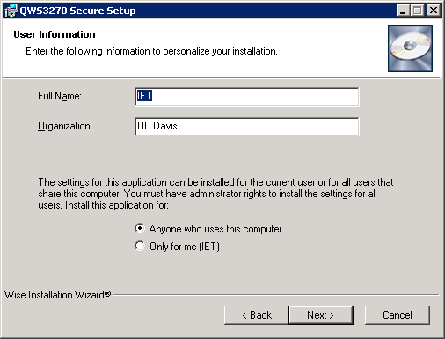

- Select Typical for the Installation Type window and click Next.
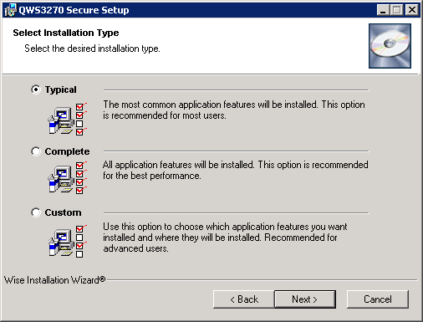
- Leave the default for the Select User Interface Language and click Next.
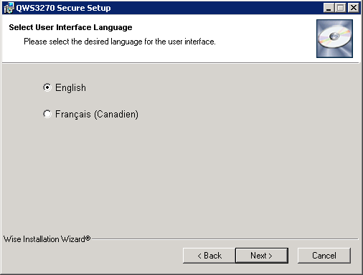
- Click Next to begin the installation.
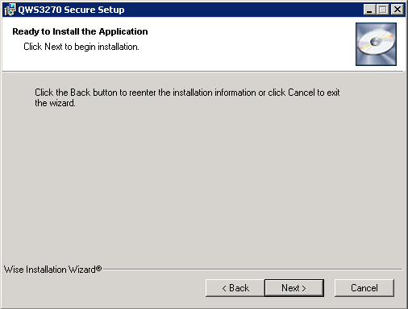

- Click Finish to complete the installation
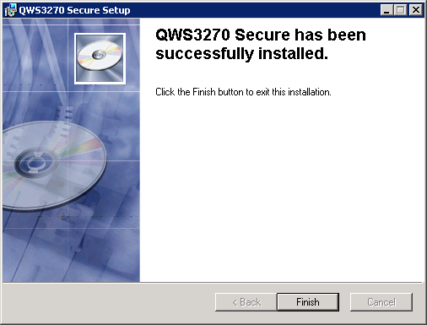
- Copy the provided QWS3270S.ini file to the following directory before launching the application.
  - XP and Windows 7: C\Program Files\QWS3270
  - Windows 7 64bit: C:\Program Files (x86)\QWS3270 Secure application

If you launch the application prior to copying the QWS3270S.ini to the program files directory, the application will default to using a Session File configuration rather than the QWS3270S.ini. You will be presented with the New Session Wizard.

Follow the steps below to change the application setting back to Use .ini file.
  - In the QWS3270 session, go to Options > Application
  - Change from Use Session File to Use .ini file
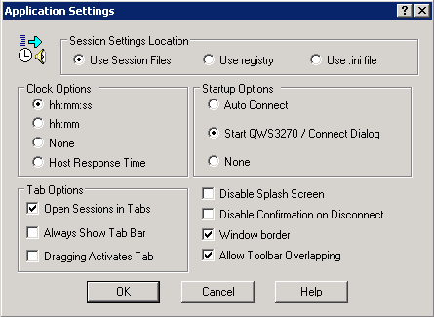
  - Click OK
  - Close the QWS3270 session
  - Got to the following directory and delete the Jolly Giant Software folder.
    - Windows XP: C:\Documents and Settings\username\Application Data\
    - Windows 7: C:\Users\ljthao\AppData\Roaming\
  - Copy over a fresh copy of the QWS3270S.ini file into the program files > QWS3270 Secure folder prior to launching QWS3270. (Most likely the previous copy if one was present would have been modified by the program.)
  - Double click on the QWS3270S icon, QWS3270S should connect to uccmvsb.ucop.edu
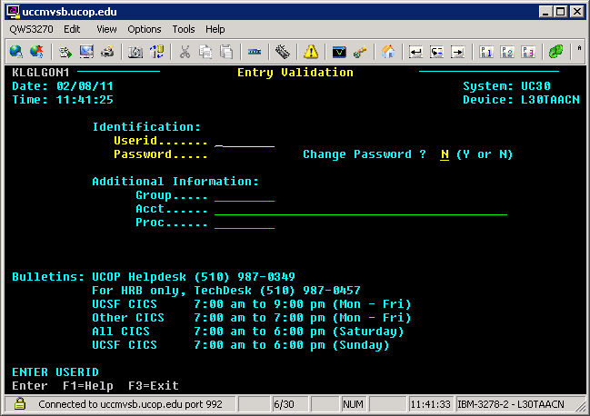

QWS3270 Manual Configuration ( Using Session File):

- Double click on QWS3270 icon to start the program. If this is the first time you are running QWS3270, the New Session Wizard will start up. Click Next to continue.
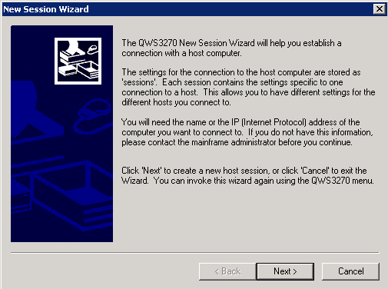
- Please enter the host name of the computer you would like to connect in the space provided. Enter uccmvsb.ucop.edu. Click Next
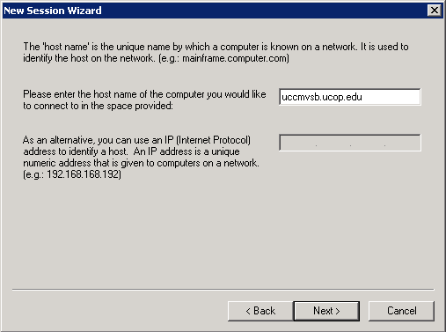
- Change the port number to 992. Click Next.
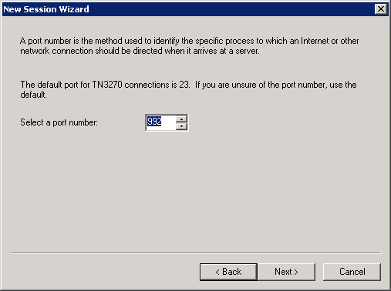
- Leave the display size with the default settings and click Next.
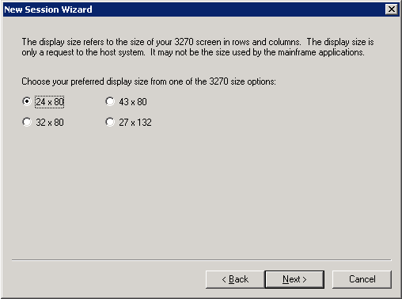
- Enter the session name (uccmvsb.ucop.edu) and click Next.
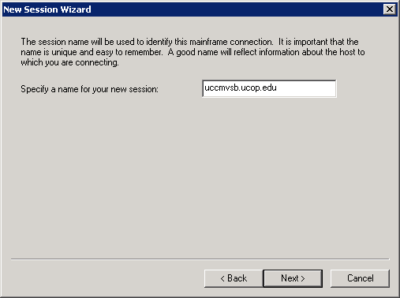
- Click Finish to close the New Session Wizard.
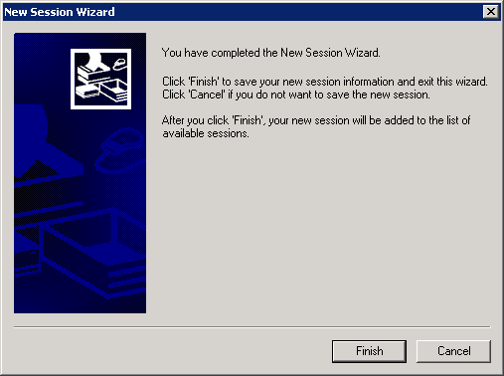

- The connection window will pop up once the session wizard has completed. Click Connect to test your configuration.
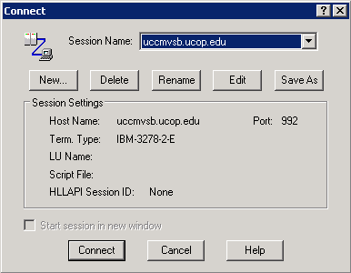
- Once connected to uccmvsb.ucop.edu, you should see the login screen for PPS.
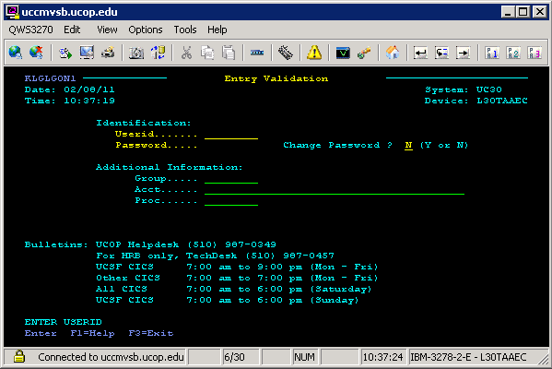

- New Session Wizard creates a session configuration file %session_name%.jgp

QWS3270 Installation defaults to using session file

- Session file Configuration for QWS3270S v4.6 can be found in the following directory under the extension *.jgp
  - Windows XP: C:\Documents and Settings\username\Application Data\Jolly Giant Software\QWS3270 Secure
  - Windows 7: C:\Users\ljthao\AppData\Roaming\Jolly Giant Software\QWS3270 Secure
- .ini file configuration for QWS3270S v4.6
  - Windows XP: C:\Program Files\QWS3270 Secure
  - Windows 7: C:\Program Files\QWS3270 Secure
  - Windows 7 64bit: C:\Program Files (x86)\QWS3270 Secure

